**SRM INSTITUTE OF SCIENCE AND TECHNOLOGY**

**DEPARTMENT OF COMPUTER SCIENCE AND ENGINEERING**

**KATTANKULATHUR – 603 203**

**15IT304J- Web Programming Register Number: RA1711003011471**

**Name: Manvi Singh Chandel**

**Experiment No: 3**

**Date: 27/08/2020**

**Aim:** **Validate the Registration, user login, user profile, pages using JavaScript**

**Input:**

**HTML Code:-**

<!DOCTYPE html>

<html lang="en">

<head>

<meta charset="utf-8">

<title>JavaScript Form Validation using a sample registration form</title>

<meta name="keywords" content="example, JavaScript Form Validation, Sample registration form" />

<meta name="description" content="This document is an example of JavaScript Form Validation using a sample registration form. " />

<link rel='stylesheet' href='js-form-validation.css' type='text/css' />

<script src="sample-registration-form-validation.js"></script>

</head>

<body onload="document.registration.userid.focus();">

<h1>Registration Form</h1>

<form name='registration' onSubmit="return formValidation();">

<ul> <li><label for="userid">User id:</label></li>

<li><input type="text" name="userid" size="12" /></li>

<li><label for="passid">Password:</label></li>

<li><input type="password" name="passid" size="12" /></li>

<li><label for="username">Name:</label></li>

<li><input type="text" name="username" size="50" /></li> <li><label for="address">Address:</label></li> <li><input type="text" name="address" size="50" /></li> <li><label for="country">Country:</label></li> <li><select name="country"> <option selected="" value="Default">(Please select a country)</option> <option value="AF">Australia</option> <option value="AL">Canada</option> <option value="DZ">India</option> <option value="AS">Russia</option> <option value="AD">USA</option> </select></li> <li><label for="zip">ZIP Code:</label></li> <li><input type="text" name="zip" /></li> <li><label for="email">Email:</label></li> <li><input type="text" name="email" size="50" /></li> <li><label id="gender">Sex:</label></li> <li><input type="radio" name="msex" value="Male" /><span>Male</span></li> <li><input type="radio" name="fsex" value="Female" /><span>Female</span></li> <li><label>Language:</label></li> <li><input type="checkbox" name="en" value="en" checked /><span>English</span></li> <li><input type="checkbox" name="nonen" value="noen" /><span>Non English</span></li> <li><label for="desc">About:</label></li> <li><textarea name="desc" id="desc"></textarea></li> <li><input type="submit" name="submit" value="Submit" /></li> </ul> </form>

</body> </html>

**CSS Code:-**

h1 { margin-left: 70px; } form li { list-style: none; margin-bottom: 5px; } form ul li label{ float: left; clear: left; width: 100px; text-align: right; margin-right: 10px; font-family:Verdana, Arial, Helvetica, sans-serif; font-size:14px; } form ul li input, select, span { float: left; margin-bottom: 10px; } form textarea { float: left; width: 350px; height: 150px; } [type="submit"] { clear: left; margin: 20px 0 0 230px; font-size:18px } p { margin-left: 70px; font-weight: bold; }

**JAVA Script Code on submit button:-**

function formValidation() { var uid = document.registration.userid; var passid = document.registration.passid; var uname = document.registration.username; var uadd = document.registration.address; var ucountry = document.registration.country; var uzip = document.registration.zip; var uemail = document.registration.email; var umsex = document.registration.msex; var ufsex = document.registration.fsex; if(userid_validation(uid,5,12)) { if(passid_validation(passid,7,12)) { if(allLetter(uname)) { if(alphanumeric(uadd)) { if(countryselect(ucountry)) { if(allnumeric(uzip)) { if(ValidateEmail(uemail)) { if(validsex(umsex,ufsex)) { } } } } } } } } return false; }

**JavaScript function for validating userid:-**

function userid_validation(uid,mx,my) { var uid_len = uid.value.length; if (uid_len == 0 || uid_len >= my || uid_len < mx) { alert("User Id should not be empty / length be between "+mx+" to "+my); uid.focus(); return false; } return true; }

**JavaScript function for validating password:-**

function passid_validation(passid,mx,my) { var passid_len = passid.value.length; if (passid_len == 0 ||passid_len >= my || passid_len < mx) { alert("Password should not be empty / length be between "+mx+" to "+my); passid.focus(); return false; } return true; }

**JavaScript code for validating user name:-**

function allLetter(uname) { var letters = /^[A-Za-z]+$/; if(uname.value.match(letters)){ return true; } else { alert('Username must have alphabet characters only'); uname.focus(); return false; } }

**JavaScript code for validating user address:-**

**function alphanumeric(uadd) {**

**var letters = /^[0-9a-zA-Z]+$/;**

**if(uadd.value.match(letters)) {**

**return true; } else**

**{ alert('User address must have alphanumeric characters only');**

**uadd.focus(); return false; } }**

**JavaScript code for validating country:-**

**function countryselect(ucountry)**

**{ if(ucountry.value == "Default")**

**{ alert('Select your country from the list');**

**ucountry.focus(); return false; }**

**else { return true; }}**

**JavaScript code for validating ZIP code:-**

**function allnumeric(uzip) {**

**var numbers = /^[0-9]+$/;**

**if(uzip.value.match(numbers)) {**

**return true; }**

**else { alert('ZIP code must have numeric characters only');**

**uzip.focus(); return false;**

**} }**

**JavaScript code for validating email format:-**

**function ValidateEmail(uemail)**

**{ var mailformat = /^\w+([\.-]?\w+)*@\w+([\.-]?\w+)*(\.\w{2,3})+$/;**

**if(uemail.value.match(mailformat)) {**

**return true; } else**

**{ alert("You have entered an invalid email address!");**

**uemail.focus(); return false;**

**} }**

**JavaScript code for validating gender:-**

**function validsex(umsex,ufsex) { x=0;**

**if(umsex.checked) { x++;**

**} if(ufsex.checked) { x++; }**

**if(x==0) { alert('Select Male/Female');**

**umsex.focus(); return false;}**

**else { alert('Form Successfully Submitted');**

**window.location.reload()**

**return true;} }**

**OUTPUT:-** 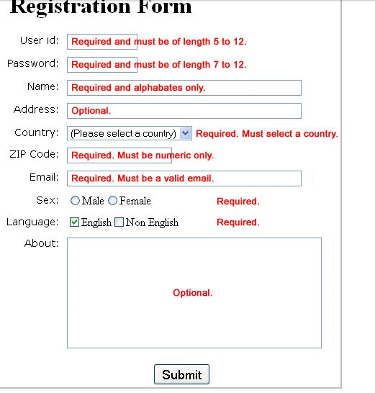

**Result: A Validation Form using JavaScript was created.**